Exploring Genetic Variation in a Caffeine Metabolism gene
LAB TWO: POLYMERASE CHAIN REACTION

Purpose: In this laboratory, we will set up a polymerase chain reaction to amplify the region of the caffeine gene we would like to study. We will be using the DNA you isolated yesterday as starting material.

Background
Today we will be amplifying the CYP1A2 gene region using a process called Polymerase Chain Reaction (PCR). PCR is a process by which specific regions of DNA are amplified. If you achieve success, we will use restriction enzymes to cut the CYP1A2 gene. Depending on which polymorphism, or difference, your DNA has, the DNA will cut to different sizes, which can be detected by running the DNA on an agarose gel. While in theory we could try to cut the gene directly from your genomic DNA, your DNA is huge, with millions of base pairs per chromosome. This is extremely unwieldy and impossible to distinguish. However, by amplifying CYP1A2 using PCR first, we target only the DNA region we are interested in (approximately 750 base pairs). Furthermore, because PCR results in thousands of copies of this region, we will have much more DNA of that region than exists in your genome to examine.

PCR is a simple technique used in a whole range of applications from identifying viruses, to crime scene analysis, to diagnosing diseases, to identifying the illegally caught fish, to sequencing entire genomes. It is one of the most important biological techniques developed. The process mimics DNA replication by utilizing the enzyme DNA polymerase taken from special bacteria that live in hot springs. The PCR reaction is performed in very small tubes with special thin walls to allow the temperature to change in the solutions inside very quickly. The machine that permits this reaction is called a thermocycler. It basically heats and cools the tubes for various lengths of time as needed. The important components of a PCR reaction are as follows:
- Taq DNA polymerase: A version of polymerase taken from thermophilic (heat-loving) bacteria. It is extremely heat-tolerant, which is important to this procedure, since pulling apart two DNA strands requires heating to near boiling temperatures.
- DNA template: Your DNA. Because PCR makes copies of DNA, you only need a tiny amount, in this case, 50ng.
- Primers: Short, single stranded pieces of DNA complementary to each end of the region being amplified. Primers specifically bind to the complementary DNA region within the genome and allow the polymerase to start adding base pairs.
- dNTPs: A mixture of adenine, guanine, cytosine, and thymine deoxyribonucleotides. These are the building blocks of DNA and serve as the raw material as the DNA strands are built by DNA polymerase.
- Buffer: Contains salts and ions needed to create the proper pH environment for the reactions to occur.

The process of PCR involves many cycles (see Figure below). Each cycle has the following steps:
- Denaturation step: The reaction is heated to 94ºC to allow DNA strands to unwind and separate, or melt. (Note: Most DNA polymerase enzymes from most organisms (including us) stop working at this temperature. However, because Taq DNA polymerase came from bacteria that live in hot springs, it is unaffected and will still be functional for step 3.)
- Annealing step: The reaction is cooled to 50ºC to allow the primers to stick to complementary regions of the template DNA, setting the stage for the DNA polymerase. (This temperature is too cold for Taq DNA polymerase to function well.)
- Extension step: The reaction is heated to 68ºC, a temperature where DNA stays bound together, but the Taq DNA polymerase enzyme is optimally functional. The enzyme starts at the primer and fills in bases complementary to the template strand.
These three steps (1 cycle) are repeated 35 times. Each time the cycle is repeated, the number of copies grows exponentially until you have millions of copies.

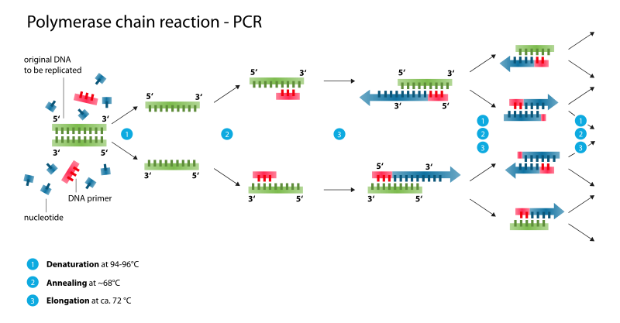
Copyright: Wikimedia Commons/enzoklop

Procedure: Set up PCR
- Determine the concentration of your DNA using the nanodrop spectrophotometer. This equipment determines how much light can shine through your DNA sample at a particular wavelength (260nm). The more DNA you have, the less light that can pass through. Write the concentration of your DNA here: ___________ng/µL.
- In addition, the spectrophotometer will tell you how much protein is left in your sample by reading the wavelength at 280nm. The best DNA to protein ratio is to have a 260:280 ratio of 1.8. Write the 260:280 ratio of your DNA here:_____________.
- Dilute your DNA to a concentration of 10ng/µL in 100µL of water if necessary. You will use 5µL (50ng) as your DNA template.
- Label a very small PCR tube on the side with your initials.
- Each reaction will contain the following: primers, MgCl₂, Taq buffer, dNTPs, and Taq DNA polymerase. This is a MasterMix, and everything that is the same across everyone’s PCRs will be mixed into one tube that all students can use. The only thing that is left out is the component that is unique, in this case, the DNA template. Each student should combine 45µL of the MasterMix with 50ng (5µL) of template DNA in a well-labeled PCR tube. Make sure to pipet both solutions (MasterMix and DNA) into the very bottom of the tube.
- The reactions will be cycled as indicated in the chart.
- Tomorrow, we will digest your PCR using restriction enzymes.

Stage | Temp | Time | # of Cycles
Initial Denaturation | 94°C | 5 min | 1
Denaturation | 94°C | 30 sec | 35
Annealing | 58°C | 30 sec
Extension | 68°C | 1 min
Final Extension | 68°C | 5 min | 1
Hold | 4°C | Indefinitely

Concept Check and Challenge Questions
1. The sequence of one part of the DNA is GGAGATCG. What is the complementary DNA sequence?
______________________________________________________________________________

2. Draw a picture in the chart to demonstrate what your DNA looks like at each step during the PCR. Include the primers.
Temperature | Image
DNA at room temperature
DNA at 94°C
DNA at 58°C
DNA at 68°C after one cycle

3. Like SNPs, differences in short tandem repeats (STRs) are used to distinguish individuals and can be used in forensic analysis. DNA from suspects (individuals A, B, C, D) and DNA from a crime scene (forensic sample F) is amplified by PCR, cut, and separated via gel electrophoresis to generate a profile, or DNA fingerprint. Each individual has a unique restriction fragment length polymorphism, or RFLP. A comparison can then be made to determine who committed the crime. When examining 5 to 10 different STRs, the odds that two random individuals would share the same profile by chance are approximately one in 10 billion. In the image below, which individual matches the forensic evidence and therefore, likely committed the crime?
F A B C D
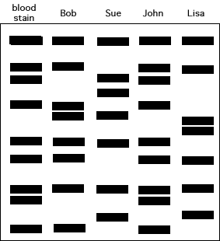
Copyright: SURESH PAWAR
4. Would you accept this as more reliable evidence in a criminal case than an eyewitness report? Why or why not?

5. Why do you think PCR was a necessary step to analyze the data and identify the criminal?

